  
  
  
  
CS 319 - Object-Oriented Software Engineering  
Final Report  
  
  
Project Name: Survival in Bilkent

Group 2-M

Pelin Elbin Günay - 21402149

Kübra Nur Güzel - 21400946

Alper Şahıstan - 21501207

Semih Teker – 21300964

Table of Contents

1. Changes in the Implementation 3

1.1. Change in Libraries 3

1.2. Removal of EnemyBullet Class 3

1.3. Change in Dynamic Game Object 3

1.4. Abstract Shape Class 3

2. Status of the Project 3

3. User’s Guide 4

3.1. System Requirements 4

3.2. Installation 4

3.3. Overview of the Game 4

3.4. Game Entities Subsystem 5

3.4.1 Game Objects 5

3.4.2 Controls 5

3.4.3 Game Screenshots 5

# Changes in the Implementation

### Change in Libraries

Instead of AWT Swing we have decided to use Slick2D library for our project. This will allow us not to write a Vector2 class and use Vector2f class from the library for our game screen.

### Removal of EnemyBullet Class

We have decided to remove EnemyBullet class from our hierarchical system which was located under Game Entities Subsystem. To replace that, inside of the Bullet class, isEnemyBullet boolean will be created.

### Change in Dynamic Game Object

Instead of Vector2f velocity we are now holding float speed since movements of our objects can be defined in one dimension.

### Abstract Shape Class

Each game object will hold an instance of an abstract class “Shape” (comes from the Slick2D library) and this class will be initialized to a non-abstract “Shape” in Game Objects non-abstract child classes. (in GameObjects: Shape shape; in Player (grandchild of Game Object): shape = new Oval (3,2, 10, 15)

# Status of the Project

We have successfully completed the player object, player can move and shoot bullets. Also, a simple enemy called “Bug” that chases the player spawns on our game map. Bugs can chase enemies, but they cannot shoot. Other than that, bullets deal damage and angle of shooting is also handled. We manage to add one of the power-ups called Bouncy Bullet that bounces from the boundaries of the game map.

# User’s Guide



## System Requirements

Survival in Bilkent is a Java based game. For this reason, Java Run Environment should be present and installed to the computer in order to start the game. It can be downloaded from the following link:

<http://www.oracle.com/technetwork/java/javase/downloads/index.html>

Minimum System Requirements:

• Windows XP

• Pentium2 233 MHz CPU or higher.

• 256 MB of RAM or higher

• Screen resolution: 1080x1920

Recommended System Requirements:

• Windows 10

• Intel i5 2 GHz CPU or higher

• 1 GB of RAM or higher.

• Screen Resolution: 1080x1920

## Installation

Running and compiling our code with a Java IDE is the only way to play our game at the moment. We are planning to make an executable without needing a Java IDE.

## Overview of the Game

When the player chooses the play option from the main menu game starts. There is an empty map on the screen. There is a player icon and some enemies spawning. Player can move around the map using W, A, S, D buttons; aim and shoot with the mouse input. If the enemies take damage that is equal or more that their health, enemy dies and disappears from the map. Enemy health is visible on the enemy’s icon and decreases when bullets hits the enemy.

## Game Entities Subsystem

## Game Objects

* **Player:** That is the main object that the user controls which can move and shoot.
* **Bullet:** Player can shoot bullets that does damage to enemies.
* **Enemy:** Different type of enemies will be present in our game. Right now, there is only the “Bug” enemy can only chase down the player and try to damage it via collisions.
* **Collectables:** Objects that will give small bonusses to the player.

## Controls

* **W:** Move north
* **S:** Move south
* **A:** Move west
* **D:** Move east
* **Mouse:** Aim
* **Mouse Left Click:** Shoot
* **Mouse Right Click:** Apply the power-up

## Game Screenshots and Menus

**Main Menu:** The first thing user came across in the game is this main screen.

**Play:** This is the game screen and player will be playing the game on this screen.

Game starts with a Player and a list of enemies which is spanned on the game arena randomly.

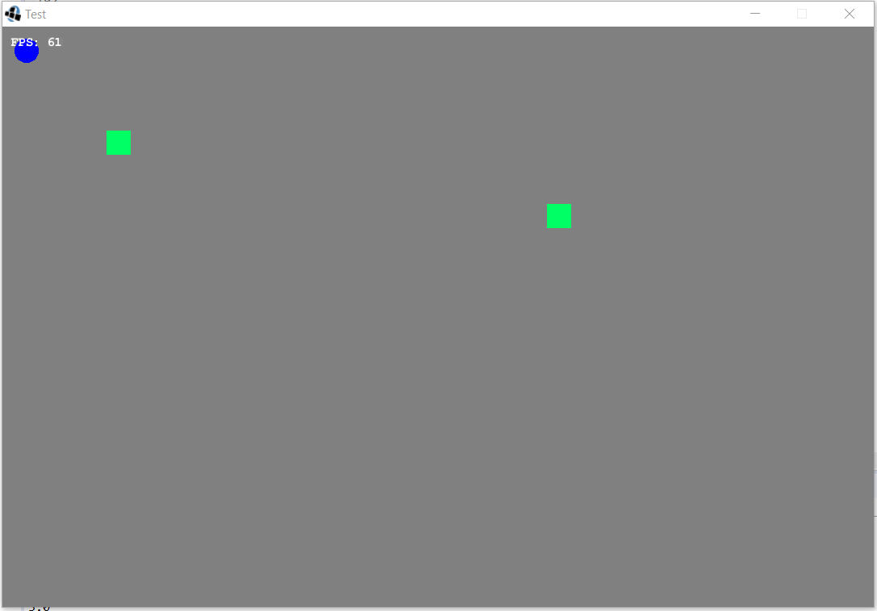

Some types of enemies follow the Player as their target to damage.

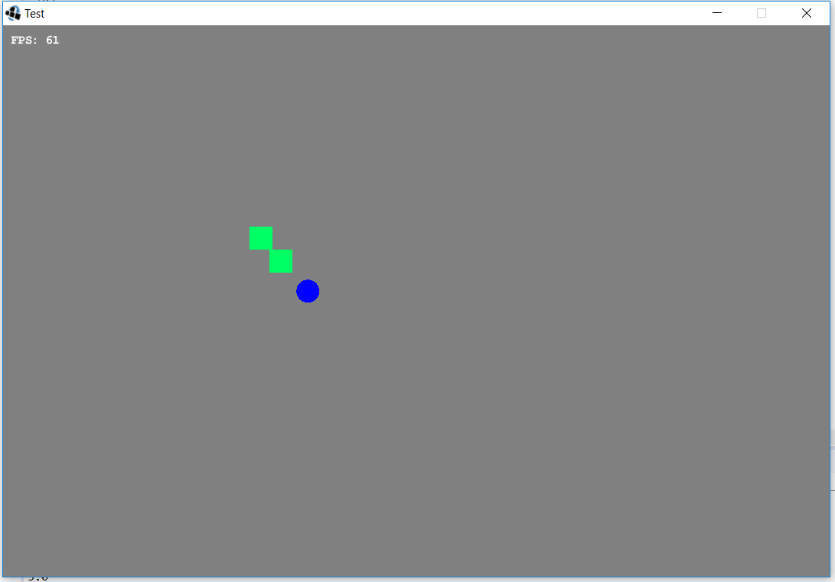

Player kills the enemies by using bullets (by clicking left click of mouse)

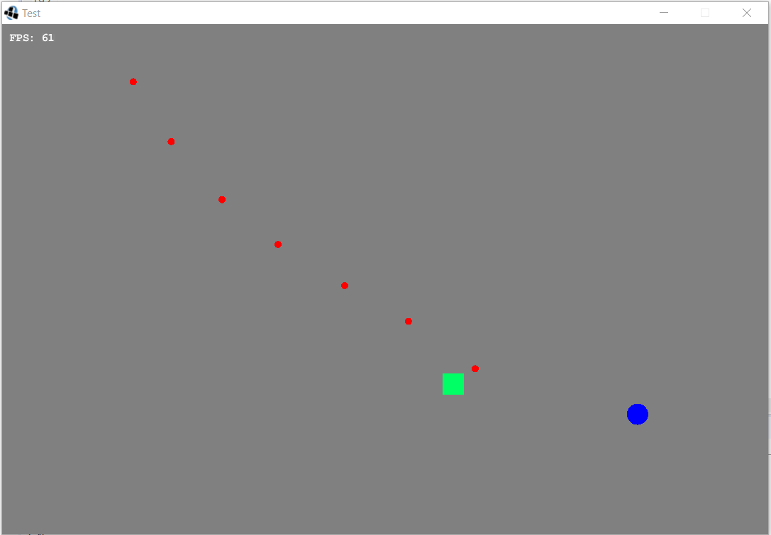

Player can change the type of the bullet by clicking right click of mouse, then bullets are changed with bouncy bullets which can bounce when they hit the boundary of screen.

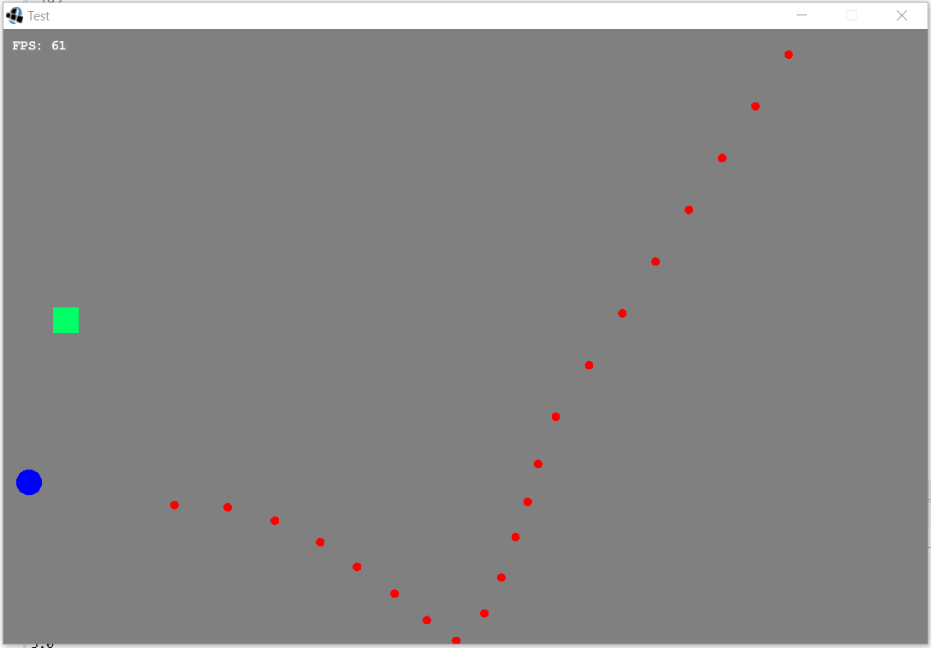

If Player wants to use normal bullets, clicks right click of mouse again.

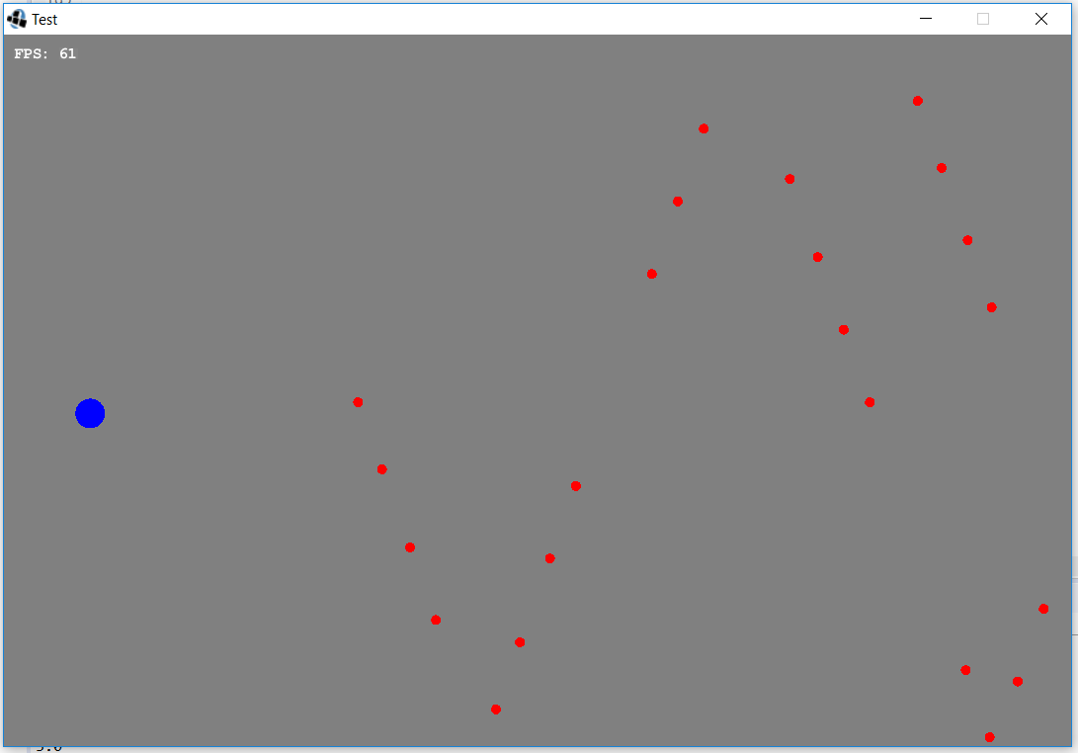

**Pause Menu:** When player decides to pause the game, this menu will appear.

**Game Over Menu:** Appears on the screen when player runs out of time.

**Level Completion Menu:** Appears when player successfully completes a level.

**Upgrade Menu:** Player will enter this menu at the end of each successful level to purchase upgrades.

**Credits:** Developers of the game will be shown here.

**Instructions:** If player click the “?” at the upper right corner of the main menu, he or she will see this page to learn about instructions.